Indian Joint Special Operations Command (IJSOC): Imperative to Integrated Theatre Doctrine
Lieutenant General (Dr) Sunil Kumar Gadeock, AVSM (Retd)

Byline:
The need for a unified special operations command in India arises from the rapidly evolving character of highly dynamic warfare and the increasing prominence of hybrid threats. Modern conflict is no longer confined to conventional battlefields but extends into domains such as information warfare, cyber operations, and cognitive influence, where speed, precision, and integration determine success.

Introduction
Victory is no longer determined solely by territorial gains, but by the multifaceted ability to achieve long-term strategic effects through calibrated applications of military and non-military power. India’s evolving security environment, marked by cross-border terrorism, hybrid warfare, and geopolitical competition, demands rapid, precise, and covert military responses. Within this context, special operations forces have emerged as critical instruments of state power. As part of ‘operational art’, they can have medium to long-term adverse effects on a nation’s defence infrastructure, requiring commensurate time for recuperation, consolidation, and retaliation.
Changing Character of Warfare and Strategic Context
Irregular forces have become central to modern conflict, with even advanced militaries like those of the United States and NATO engaged in prolonged struggles against them. China’s early advice to Pakistan to wage a prolonged proxy war laid the foundation for the use of Jihadi groups as instruments of state policy. Over the decades, Pakistan has supported and nurtured multiple terrorist organisations, which have carried out numerous attacks across India, while maintaining plausible deniability by labelling them as “non-state actors”, wherein ownership is not to be justified. Simultaneously, China has provided indirect support to insurgent groups within India and strengthened Pakistan strategically through initiatives such as the China-Pakistan Economic Corridor, and also a credible presence in Gilgit-Baltistan. This collusive strategy has expanded the scope of asymmetric warfare against India, including attempts to destabilise regions like the Northeast and exploit emerging vulnerabilities in the Indian Ocean region.
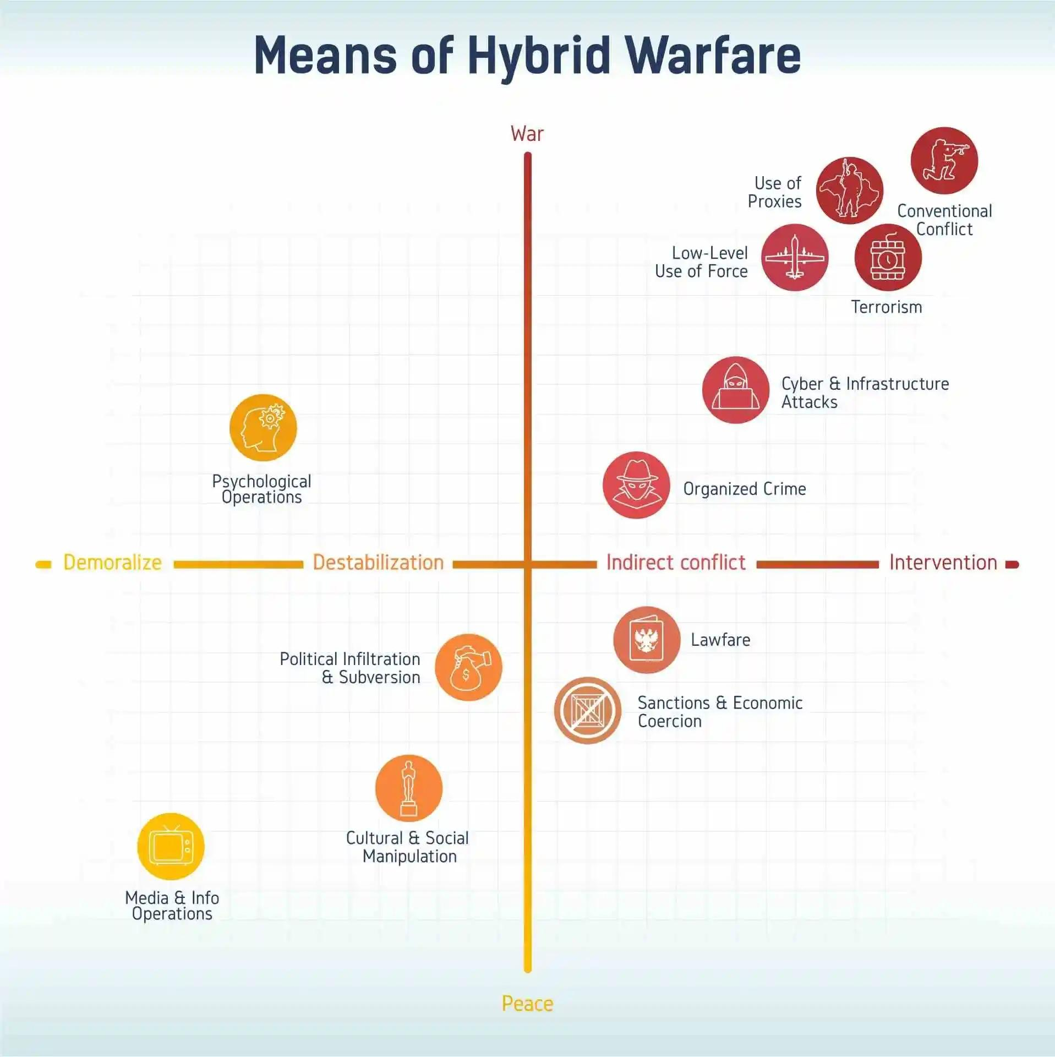Means of hybrid warfare Source - cepa.com
A major concern is India’s inadequate strategic response to these challenges. Despite being subjected to sustained proxy warfare, India continues to rely heavily on conventional military power and diplomatic engagement, reflecting a lack of an evolved strategic culture. This has created a significant asymmetry vis-à-vis China and Pakistan, both of which have developed advanced sub-conventional capabilities. India’s reluctance to fully recognise and respond to these threats has somewhat limited its multiple choices and corresponding offensive options and ability to counter terrorism effectively.
Finally, India faces an acute strategic dilemma arising from incoherent policies, brainstorming incisive military solutions, and insufficient institutionalised thinking. While adversaries increasingly employ hybrid warfare, including cyber operations, proxy conflicts, and psychological tactics, India’s responses remain reactive and fragmented. The lack of effective deterrence against irregular threats has reinforced perceptions of India as a “soft state” and exposed gaps in intelligence, coordination, and proactive strategy.
As early as 2001, such approaches, including low-intensity conflict, guerrilla warfare, and psychological operations, were openly advocated as alternatives to direct military engagement. This evolving landscape necessitates integrated responses that combine kinetic and non-kinetic capabilities across domains, so as to prognosticate any military holocaust or Armageddon in the reckoning due to the emergence of antagonistic strategic developments in the possible next few decades.

Evolution of Special Forces in India
In the early decades after independence, India primarily focused on conventional military capabilities, with limited emphasis on specialised forces for irregular operations. However, experiences such as the wars of 1962, 1965, and 1971, along with insurgencies in the Northeastern states and Jammu & Kashmir, highlighted the need for elite units capable of conducting covert, swift, and ruthless high-risk missions in a rapid succession of time. Over time, India raised specialised units within each service, but their development remained largely service-specific rather than integrated. This lack of early institutional focus on unconventional warfare contributed in fair measure to a gap in strategic capabilities, particularly when compared to adversaries that had already begun investing in irregular and proxy warfare strategies.
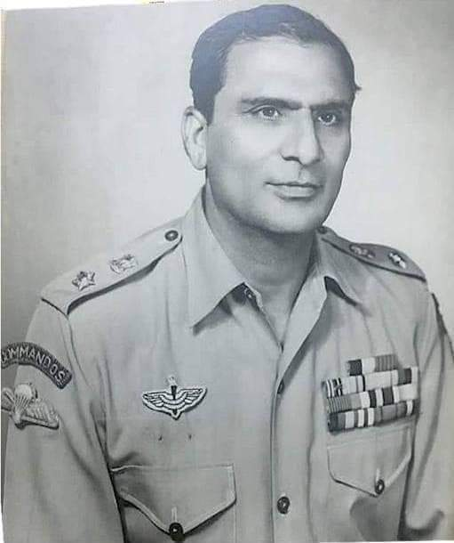Lt Col Megh Singh - founder of 9 Para Commando (later 9 Para SF) Source - rajputanacommunity.in
In India’s case, however, despite decades of exposure to sub-conventional conflict, the development of special forces capabilities remained fragmented, with inadequate integration between military and intelligence agencies. This limited the country’s ability to effectively employ special operations at the strategic level. Over the bygone years, elite units such as the Para Special Forces, MARCOS, and Garud Commando Force were established as cogent recommendations were discussed in the tri-services seminars/ webinars supporting the offensive formations for productive strategic outcomes within constricted timelines. However, their evolution remained service-centric, resulting in limited integration and coordination. Despite growing recognition of their strategic importance, the absence of a unified command structure has constrained their operational effectiveness and strategic employment.

Operational Lessons and Strategic Significance of Jointness
Indian Special Forces have demonstrated exceptional operational versatility with strategic insightfulness through a range of high-risk missions spanning counter-terrorism, rapid intervention, and cross-border strikes. One of the most prominent examples is Operation Black Tornado (2008), where National Security Guard (NSG) commandos conducted complex urban combat operations during the Mumbai terrorist attacks, involving hostage rescue, room-to-room clearance, and neutralisation of heavily armed militants.
Similarly, Operation Cactus (1988) showcased India’s rapid deployment capability, where Para (Special Forces) were airlifted over 2,000 km to the Maldives within hours to thwart a coup attempt, securing key installations and restoring political stability with minimal casualties, thereby reinforcing India’s role as a regional security provider, proving the vitality of reinstatement capabilities in the available strategic space.
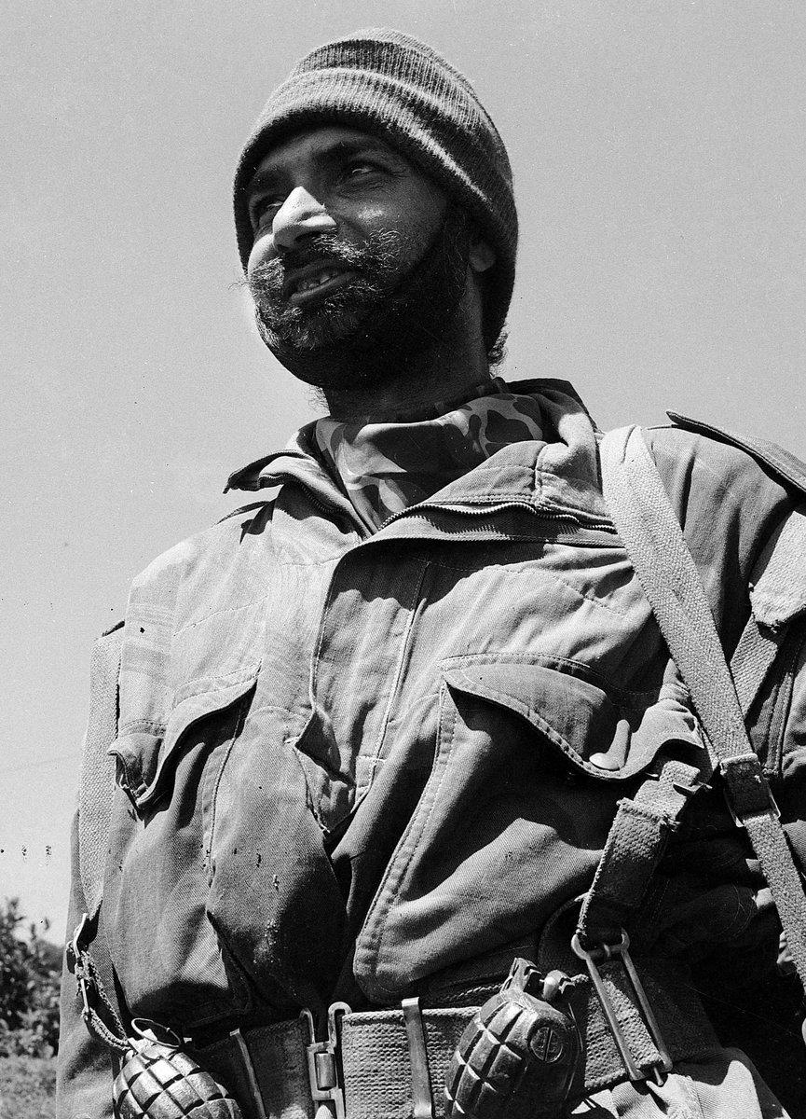Maj Ranjit Singh Dayal, MVC of 1 Para Commando (later 1 Para SF) at the Haji Pir Pass in 1965
Source - x.com/SpokespersonMoD
Another critical dimension of Indian Special Forces operations is their role in strategic deterrence and also the highly precision strikes, critical to national security. The 2016 surgical strikes across the Line of Control (LoC) in Pakistan-occupied Kashmir exemplify India’s shift toward proactive defence, where Para (SF) units conducted coordinated cross-border raids targeting terrorist launch pads with high precision and without sustaining casualties, demonstrating advanced planning, stealth, and execution capabilities. In addition, maritime operations by MARCOS in anti-piracy missions in the Indian Ocean highlight their expertise in amphibious warfare and ship-boarding tactics, contributing significantly to securing vital sea lanes and protecting global trade routes.
These recent operational experiences would abundantly demonstrate the importance of integrated, multi-domain approaches to warfare. The use of precision strikes, information operations, and strategic signalling reflects a shift toward effect-based operations (EBO) aimed at achieving deterrence without full-scale conflict. These models demonstrate that unity of command and also in the same military breadth, operational autonomy are critical for success in modern warfare.
IJSOC: Inevitable Strategic Imperative
In recent years, there has been a growing recognition of the need to transform and consolidate India’s special forces into a more cohesive, irrevocable, and strategically oriented ability for operating in a joint integrated ‘Out of Area Contingency Capability (OACC)’ with Atmanirbhar equipment and arsenals of the country. Special forces should not merely support conventional operations but serve as a central tool of national power, capable of achieving political and military objectives with precision and minimal visibility. Thus, the history of Indian special forces reflects a gradual but incomplete transition from conventional warfighting support to a critical component of modern, asymmetric warfare strategy.
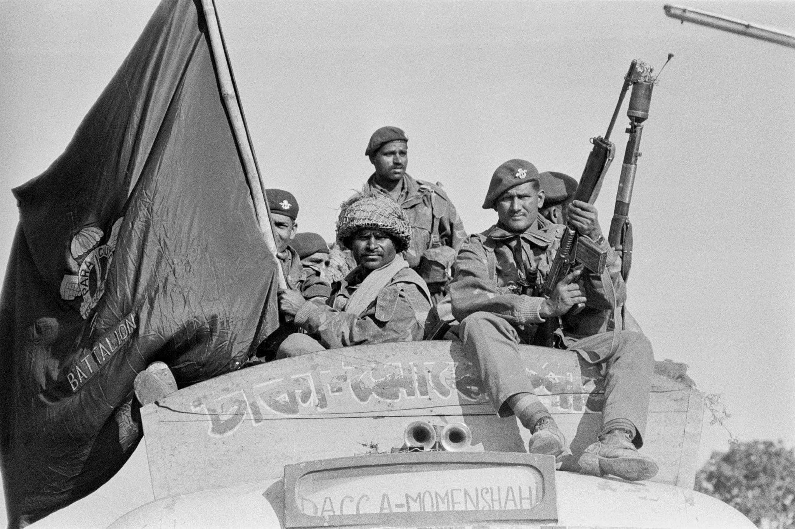Troops of 2 Para Commando (later 2 Para SF) entering Dhaka after the Tangail airdrop in 1971
Source : reddit.com/r/SpecOpsArchive
Existing military doctrines highlight that the three services, Army, Navy, and Air Force, continue to function largely within service-specific frameworks, leading to fragmented planning and execution; however, with the Chief of Defence Staff steering the overall tri-services operations, there are leveraged capability changes to the orchestration and final envisaged conclusions in the envisaged battles. For instance, standard operating procedures (SOPs) remain service-centric and do not adequately address joint planning requirements, thereby hampering operational effectiveness in complex missions. A dedicated ‘joint special forces command’ would very largely mitigate these vital issues by institutionalising unified command structures, ensuring seamless coordination, and enhancing the effectiveness quotient of high-risk, precision operations.
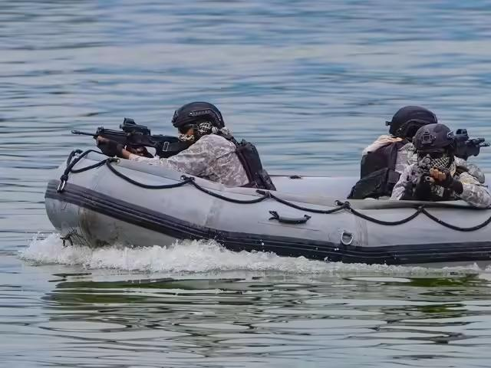Indian Navy MARCOS during exercises
Source : economictimes.indiatimes.com

However, the uneven adoption of emerging modern warfare technologies such as artificial intelligence, cyber systems, and network-centric warfare across the services reflects a lack of unified institutional architecture. A joint special forces command would act as a centralised hub to integrate all these diverse organisations and associated equipment capabilities (favourably recommended by a similar military environment SWOT Analysis), enabling real-time intelligence fusion, faster decision cycles, and coordinated execution of strategic missions such as counter-terrorism, deep strikes, and hybrid warfare operations.
Joint doctrines emphasise that no single service possesses the full spectrum of capabilities required for complex operations, particularly those involving airborne, heliborne, or special operations tasks. Special forces missions often depend on assets such as airlift, maritime insertion platforms, cyber support, and intelligence networks that cut across service boundaries. Without a unified command, such operations rely on ad hoc coordination, reducing efficiency and increasing the risk of mission failure. A joint special forces command would ensure optimal allocation of resources, unified command and control, and enhanced interoperability, thereby significantly improving India’s ability to conduct precise, swift, and effective military operations in an increasingly complex security environment.
A unified Indian Joint Special Operations Command (IJSOC) would address these vital limitations by enhancing inter-service coordination, enabling centralised planning, integrating intelligence, and improving rapid response capabilities. In an era of hybrid warfare, seamless integration across land, sea, air, cyber, and space domains is essential.
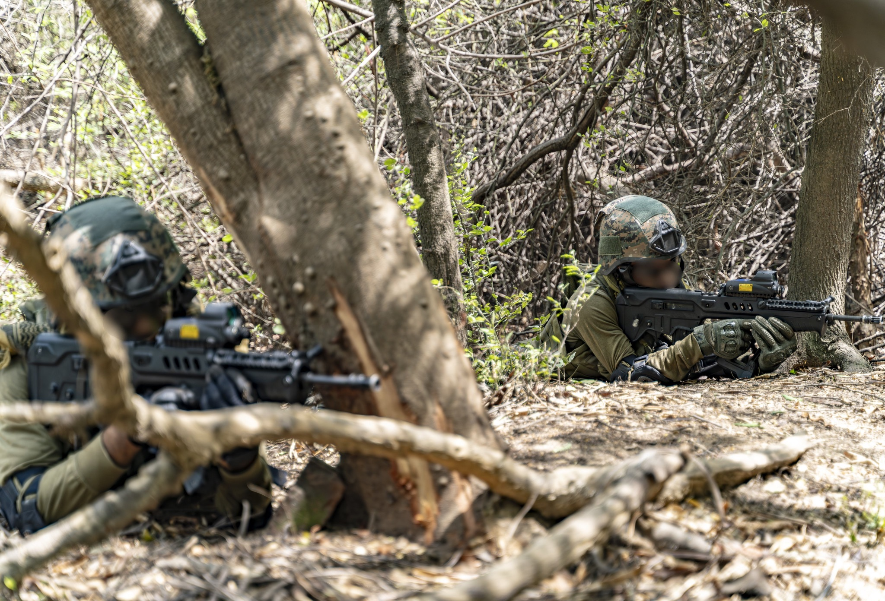IAF Garud Commandos during exercises
Image Source : reddit.com/r/IndianDefense

Institutional and Structural Challenges
Despite its strategic necessity, the establishment of a joint special forces command in India faces several structural and institutional challenges, which could be overcome by astute military commanders with rich active field experience, exercising their military brilliance. One of the primary obstacles is the lack of deep-rooted integration and jointness among the three services, with persistent “turf issues” and competition over limited resources hindering unified decision-making and cooperation. The existing command structures allow each service to retain control over its assets, making them reluctant to cede authority to a centralised command.
These challenges indicate that while a joint special forces command is strategically necessary, its implementation requires overcoming deep institutional barriers, fostering a culture of jointness, and undertaking comprehensive reforms across the national security architecture. Despite repeated recommendations, including those of the Naresh Chandra Committee, the absence of strong political will and bureaucratic resistance, particularly within the Ministry of Defence, has delayed the creation of a unified Special Operations Command.
In spite of possessing highly capable special operations units, the absence of a unified command structure remains a significant strategic limitation. The creation of an ‘Indian Joint Special Operations Command’ (IJSOC) is therefore not merely an institutional reform, but a strategic imperative which is prudently driven by operational, organisational, and geopolitical realities in the present conflict environment.
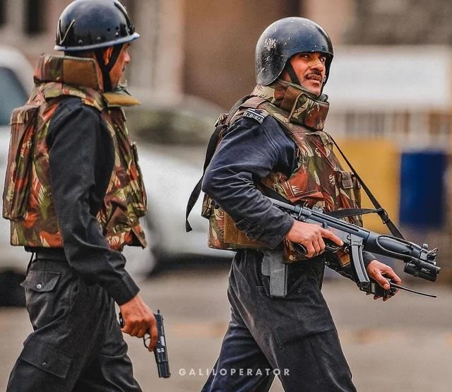NSG Commandos during 26/11
Image Source : reddit.com/r/IndianDefense

One of the most salient issues in India’s current military framework is the fragmentation and optimised integrated employment with high synergy levels of its elite forces. Units such as the Para Special Forces, MARCOS, and the Garud Commando Force operate under separate service commands, each with distinct doctrines, training standards, and operational priorities. Studies emphasise that the absence of integrated theatre and functional commands continues to constrain India’s ability to conduct joint operations effectively. Gaps in intelligence sharing and technological interoperability also remain significant obstacles, reducing the synergised effectiveness of coordinated operations.
The need for a unified special operations command in India arises from the rapidly evolving character of highly dynamic warfare and the increasing prominence of hybrid threats. Modern conflict is no longer confined to conventional battlefields but extends into domains such as information warfare, cyber operations, and cognitive influence, where speed, precision, and integration determine success.

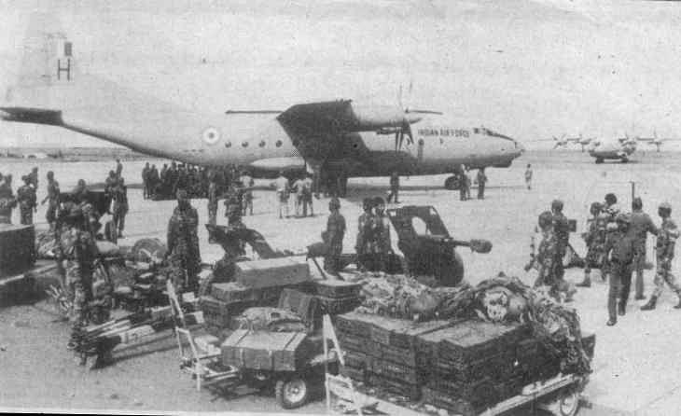Para SF troops at Male Airport in the aftermath of Op Cactus
Image Source : indiasentinels.com

The growing importance of intelligence-driven operations, precision strikes, and covert missions highlights the necessity of a centralised framework capable of integrating all elements of national power for decisive outcomes. The gap lies primarily in the lack of institutionalised jointness, resulting in duplication of effort, slower decision-making, and suboptimal resource utilisation. Service-centric doctrines, limited interoperability, and inadequate intelligence integration further constrain operational effectiveness, particularly in fast-evolving scenarios requiring seamless coordination across domains as articulated in the 2017 Indian Armed Forces Joint Doctrine.
Such a command would enhance operational synergy, enable real-time decision-making, and provide the strategic agility required for modern warfare. Drawing on global best practices, particularly models such as the United States Special Operations Command, unified command structures have demonstrated significant improvements in operational effectiveness and rapid deployment capabilities. By aligning with India’s evolving defence reforms, the IJSOC would bridge existing gaps and significantly strengthen India’s deterrence posture and national security framework.

Enabling Capabilities and Operational Advantages
The effectiveness of an IJSOC would depend on key enabling capabilities for operative jointness in the Indian military. This must rest on a coherent framework that integrates training, intelligence, technology, and financial support. Joint capabilities are not merely organisational constructs but also include cognitive and cultural dimensions such as interoperability, trust, and shared understanding. In this regard, unified training doctrines and standardised selection processes are essential to dismantle service-specific silos and foster a common operational ethos.
Equally important is the creation of an ecosystem of ownership for jointness across both civilian and military domains. Institutionalisation of jointness requires strong political backing, including the enactment of a parliamentary act to provide legal authority, clarity of roles, and continuity to reforms. Furthermore, the long-pending establishment of the Indian National Defence University is identified as a key step toward strengthening joint professional military education and fostering intellectual integration across services. The proposed Indian National Defence University (INDU) represents a critical institutional reform for strengthening joint professional military education and fostering a unified strategic culture within the armed forces.
This would not only enhance interoperability and mutual understanding but also contribute to the development of a shared doctrine and strategic outlook. In essence, operationalising the Indian National Defence University would be a decisive step towards institutionalising joint culture and bridging the intellectual and organisational gaps that continue to impede deeper jointness in India’s defence framework. By serving as the Permanent Chairman of the Chiefs of Staff Committee and heading the Department of Military Affairs (DMA), the Chief of Defence Staff (CDS) provides single-point military advice to the civilian leadership and facilitates integration between the armed forces and the Ministry of Defence. This reform reduces bureaucratic fragmentation and enhances coherence in defence planning, capability development, and prioritisation of resources.
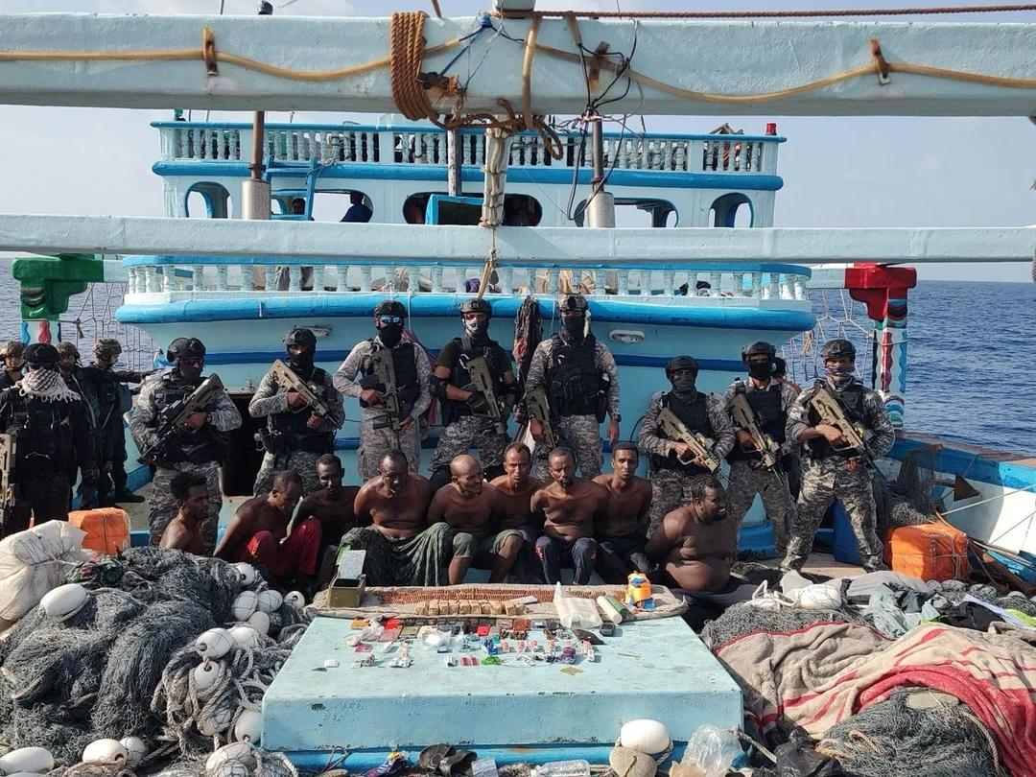MARCOS operators after an anti piracy operation
Image Source : reddit.com/r/MilitaryPorn
Moreover, the CDS plays a pivotal role in promoting joint doctrines, training, and operational planning, thereby strengthening synergy among the Army, Navy, and Air Force. Although challenges such as limited operational authority and inter-service differences persist, the creation of the CDS has laid the institutional foundation for future reforms like integrated theatre commands, marking a decisive shift from a coordination-based approach to a more integrated model of jointness. Operationally, such a command would significantly enhance India’s capabilities in counter-terrorism, strategic reconnaissance, hostage rescue, and direct-action missions. It would also strengthen deterrence by demonstrating the ability to conduct precise and high-impact operations.

Strategic Imperatives and Way Forward
The formation of the Indian Joint Special Operations Command (IJSOC) would involve transitioning from the existing fragmented command structure of Special Forces (SF) to a centralised, tri-services organisation under the Ministry of Defence, functioning directly under the Chief of Defence Staff (CDS). Placing IJSOC under the CDS would ensure integration at the highest level of military decision-making and align special operations with national military strategy. The CDS, as the principal military advisor to the government and the architect of jointness, would provide unified strategic direction, prioritisation of missions, and resource allocation for special operations. This arrangement would also facilitate seamless coordination between IJSOC and the proposed Integrated Theatre Commands (ITCs), ensuring that special operations are effectively synchronized with conventional operations.
Additionally, theatre-oriented Special Operations Task Groups would be aligned with the proposed ITCs to provide dedicated support at the operational level. The structure would also incorporate specialised branches for intelligence, logistics, communications, and training to ensure self-sufficiency. The inclusion of such integral supporting elements is critical, as current SF structures lack dedicated intelligence and sustainment capabilities, thereby limiting their effectiveness in independent operations.
A further refinement of the IJSOC structure would include the creation of functional groupings based on mission profiles such as direct action, strategic reconnaissance, counter-terrorism, and unconventional warfare. These groupings could be organised into Special Forces Groups (SFGs), each comprising elements from the three services and tailored for specific operational environments such as maritime, air, and land domains. Such modularity would enable rapid task organization and deployment while maintaining interoperability. Additionally, a dedicated ‘National Mission’ unit within IJSOC could be earmarked for politically sensitive and strategic tasks, ensuring that India retains a credible and responsive capability for high-risk operations with strategic implications. Such a centralised manpower framework would reduce duplication of roles, improve interoperability, and enable a more efficient utilisation of elite forces, which are currently dispersed across multiple commands and ministries.
A key feature of the proposed IJSOC is the incorporation of dedicated aviation assets, including both fixed-wing aircraft and helicopter squadrons. Special operations demand rapid, flexible, and often clandestine mobility, which cannot be adequately supported under the present system where SF rely on service-specific aviation resources. Dedicated aviation units within IJSOC would be specifically trained and equipped for missions such as infiltration and exfiltration, combat search and rescue, and precision strike support. Fixed-wing aircraft would enable long-range insertion and strategic mobility, while helicopters would provide tactical lift and support in diverse operational environments. The integration of these aviation assets, alongside intelligence and fire support systems, would significantly enhance the operational reach, responsiveness, and effectiveness of SF in achieving strategic objectives.
These would include dedicated aviation units, sustainment elements, intelligence units, and a signals battalion integrated within the command structure. Organic aviation assets would provide assured mobility, while sustainment units would handle logistics, maintenance, and supply chains essential for prolonged operations. The integration of these components within IJSOC is essential to overcome current dependencies on external support and to enable seamless execution of complex, high-tempo special operations in diverse operational environments. A coordinated “whole-of-government” approach, integrating military, intelligence, and political institutions, will be critical for achieving the desired outcomes.
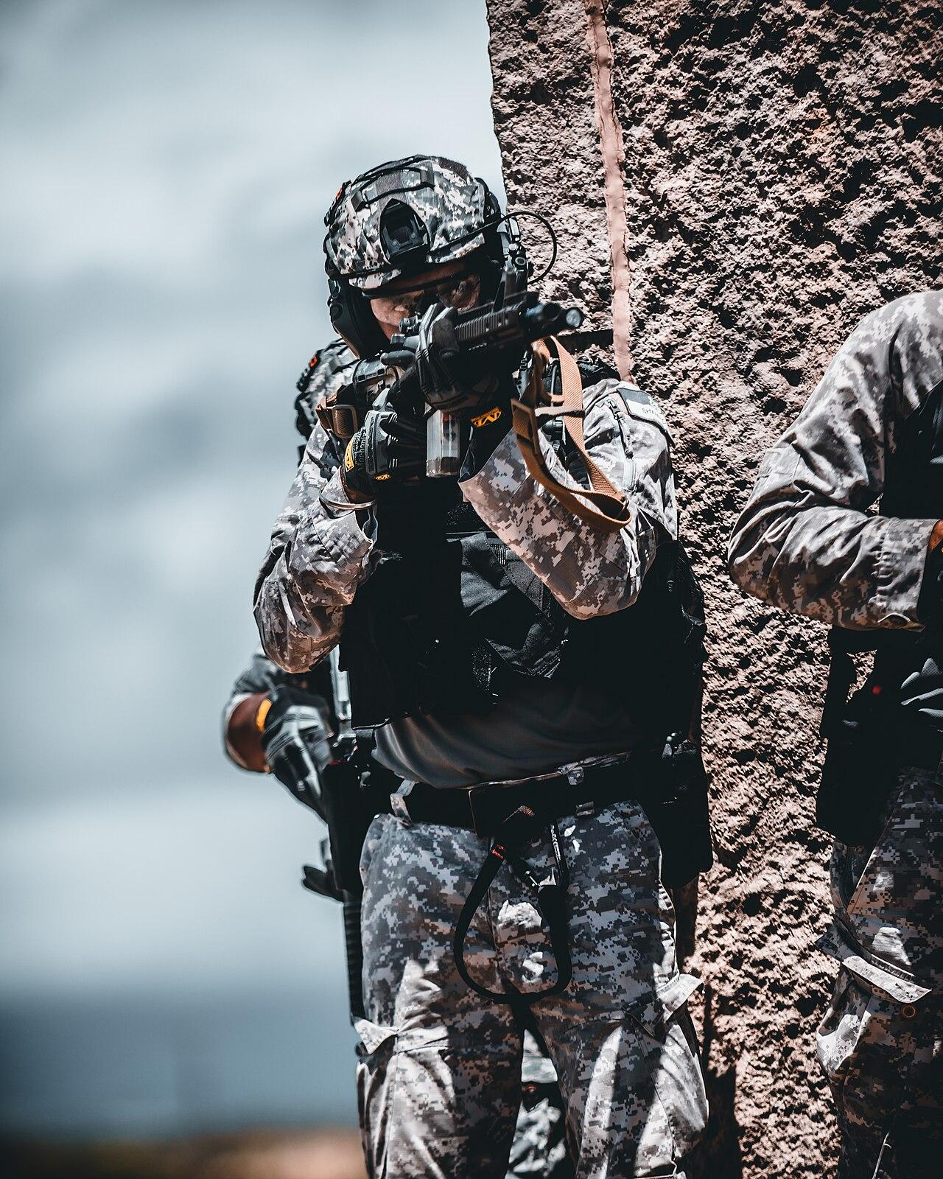An Indian Marine Commando during special operations urban combat training as part of Rim of the Pacific (RIMPAC) 2022 - MARCOS
Image Source : wikipedia.org

Conclusion
While Indian Special Forces have consistently demonstrated exceptional capability and professionalism in diverse operational contexts, their fragmented employment and service-centric organisation continue to limit their full strategic potential. This bit of dichotomy between capability and structure underscores a ‘critical gap’ in India’s national security architecture. A shift is required towards a more proactive and coherent strategic culture, one that recognises the centrality of multi-domain operations and the importance of synergy between military, intelligence, and political institutions.
However, the success of this transformation will depend not only on structural changes but also on overcoming deep-rooted institutional, cultural, and bureaucratic challenges. The creation of IJSOC must be supported by sustained political will, doctrinal clarity, joint training, and the development of an ecosystem that fosters trust, interoperability, and shared ownership across services. A unified and empowered special operations command would not only bridge existing operational gaps but also position India to respond decisively to emerging threats, ensuring strategic resilience and maintaining its stature as a credible and capable security provider in an increasingly uncertain world.

